**AZ900 PART-1: CLOUD CONCEPTS(25-30%)**

**Learning objectives**

After completing this part, you’ll be able to:

1. Define cloud computing.
2. Describe the shared responsibility model.
3. Define cloud models, including public, private, and hybrid.
4. Identify appropriate use cases for each cloud model.
5. Describe the consumption-based model.
6. Compare cloud pricing models.
7. Describe the benefits of high availability and scalability in the cloud.
8. Describe the benefits of reliability and predictability in the cloud.
9. Describe the benefits of security and governance in the cloud.
10. Describe the benefits of manageability in the cloud.
11. Describe infrastructure as a service (IaaS).
12. Describe platform as a service (PaaS).
13. Describe software as a service (SaaS).
14. Identify appropriate use cases for each cloud service (IaaS, PaaS, SaaS).

**Cloud computing** is the delivery of computing services over the internet. Computing services include common IT infrastructure such as virtual machines, storage, databases, and networking. Cloud services also expand the traditional IT offerings to include things like Internet of Things (IoT), machine learning (ML), and artificial intelligence (AI)

With the **shared responsibility model**, these responsibilities get shared between the cloud provider and the consumer. Physical security, power, cooling, and network connectivity are the responsibility of the cloud provider. The consumer isn’t collocated with the datacenter, so it wouldn’t make sense for the consumer to have any of those responsibilities.

At the same time, the consumer is responsible for the data and information stored in the cloud. (You wouldn’t want the cloud provider to be able to read your information.) The consumer is also responsible for access security, meaning you only give access to those who need it.

The shared responsibility model is heavily tied into the cloud service types (covered later in this learning path): **infrastructure as a service (IaaS**), **platform as a service (PaaS), and software as a service (SaaS).** IaaS places the most responsibility on the consumer, with the cloud provider being responsible for the basics of physical security, power, and connectivity. On the other end of the spectrum, SaaS places most of the responsibility with the cloud provider. PaaS, being a middle ground between IaaS and SaaS, rests somewhere in the middle and evenly distributes responsibility between the cloud provider and the consumer.

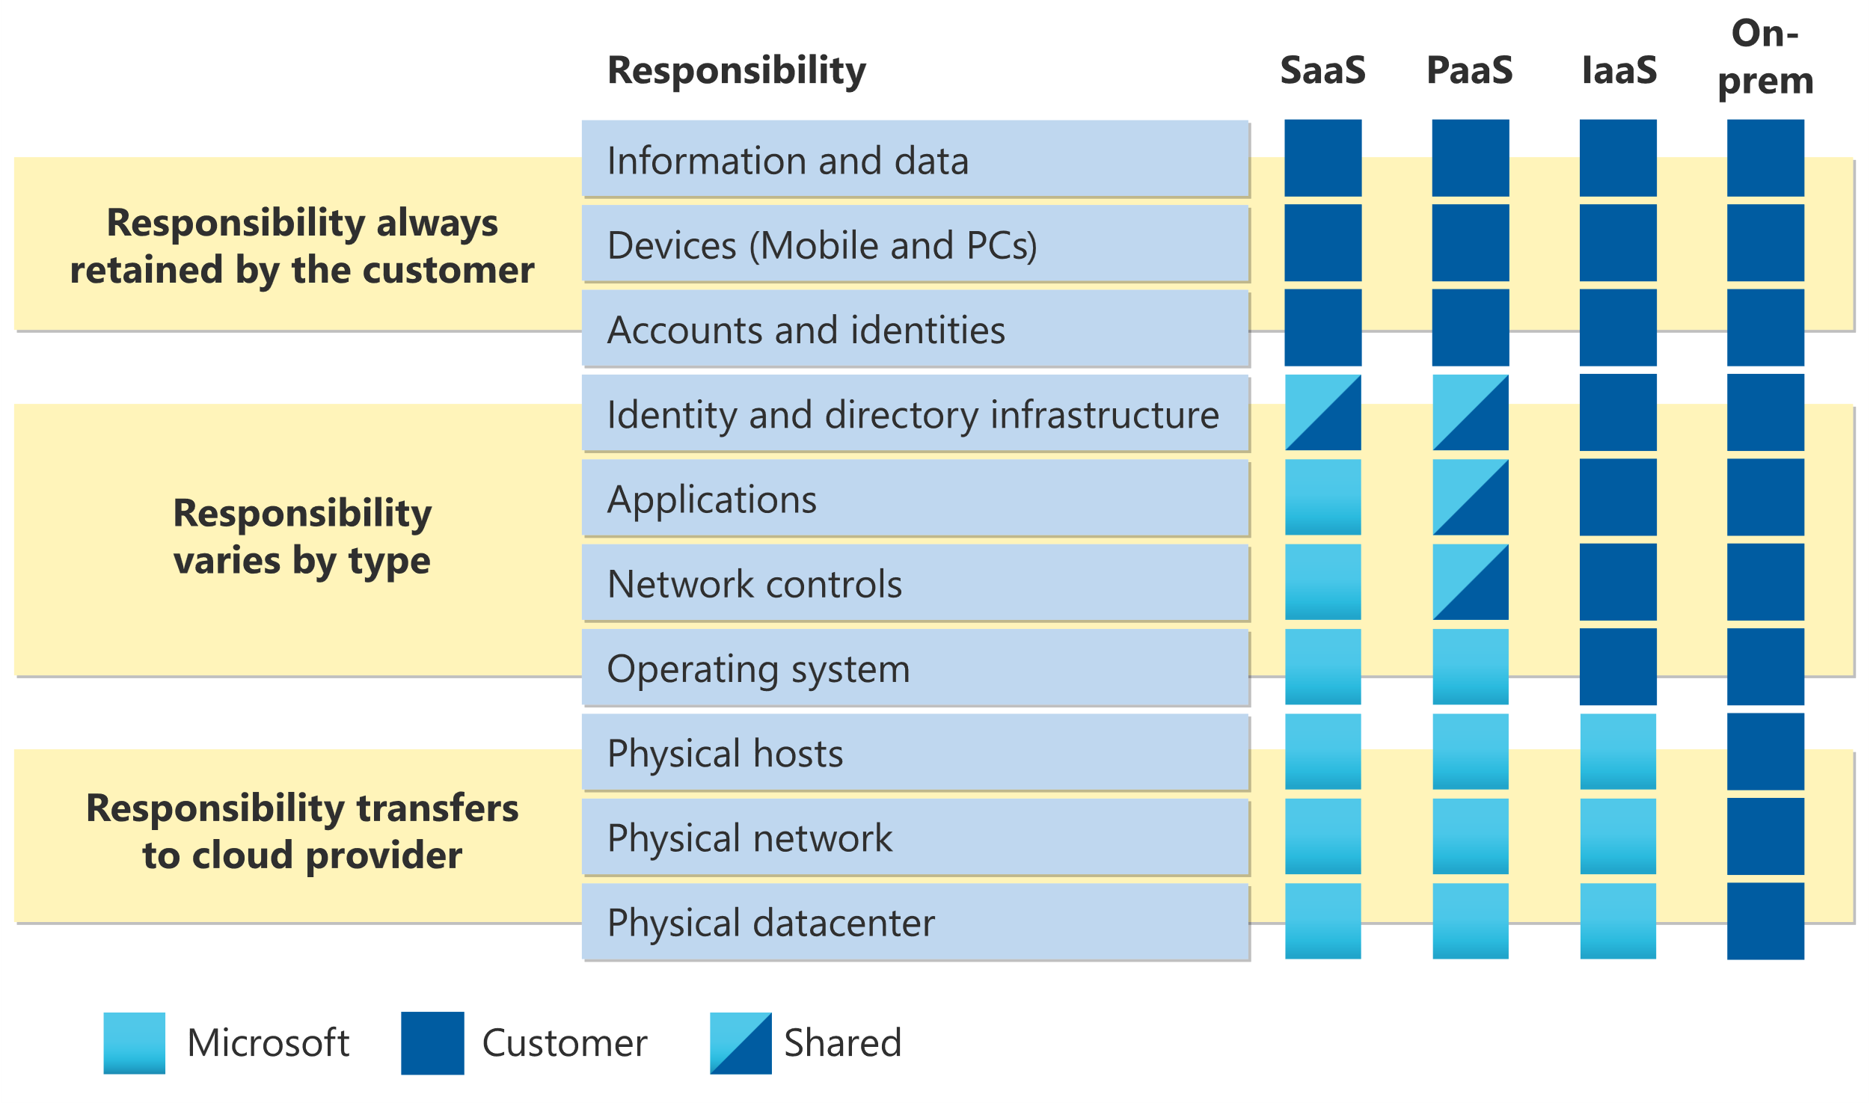

What are **cloud models**? The cloud models define the deployment type of cloud resources. The three main cloud models are: **private, public, and hybrid.**

**Private Cloud:** cloud (delivering IT services over the internet) that’s used by a single entity, comes with greater cost and fewer of the benefits of a public cloud deployment.

**Public Cloud:** A public cloud is built, controlled, and maintained by a third-party cloud provider. With a public cloud, anyone that wants to purchase cloud services can access and use resources.

**Hybrid Cloud:** A hybrid cloud is a computing environment that uses both public and private clouds in an inter-connected environment.

**Multi Cloud:** In a multi-cloud environment you deal with two (or more) public cloud providers and manage resources and security in both environments.

**Azure Arc** is a set of technologies that helps manage your cloud environment irrespective of the type of cloud.

**Azure VMware Solution**

What if you’re already established with VMware in a private cloud environment but want to migrate to a public or hybrid cloud? Azure VMware Solution lets you run your VMware workloads in Azure with seamless integration and scalability.

**The consumption-based model**

When comparing IT infrastructure models, there are two types of expenses to consider**. Capital expenditure (CapEx) and operational expenditure (OpEx).**

CapEx is typically a one-time, up-front expenditure to purchase or secure tangible resources. A new building, repaving the parking lot, building a datacenter, or buying a company vehicle are examples of CapEx.

In contrast, OpEx is spending money on services or products over time. Renting a convention center, leasing a company vehicle, or signing up for cloud services are all examples of OpEx.

Cloud computing falls under OpEx because cloud computing operates on a consumption-based model. With cloud computing, you don’t pay for the physical infrastructure, the electricity, the security, or anything else associated with maintaining a datacenter. Instead, you pay for the IT resources you use. If you don’t use any IT resources this month, you don’t pay for any IT resources.

This consumption-based model has many benefits, including:

* No upfront costs.
* No need to purchase and manage costly infrastructure that users might not use to its fullest potential.
* *The ability to pay for more resources when they're needed.*
* *The ability to stop paying for resources that are no longer needed.*

Cloud computing is the delivery of computing services over the internet by using a **pay-as-you-go pricing model.** Instead of maintaining CPUs and storage in your datacenter, you rent them for the time that you need them. The cloud provider takes care of maintaining the underlying infrastructure for you~

------------------------------------------------------------------------------------------------------

When building or deploying a cloud application, two of the biggest considerations are **uptime (or availability) and the ability to handle demand (or scale).**

**High availability** focuses on ensuring maximum availability, regardless of disruptions or events that may occur.

**Scalability** refers to the ability to adjust resources to meet demand. If you suddenly experience peak traffic and your systems are overwhelmed, the ability to scale means you can add more resources to better handle the increased demand.

Scaling generally comes in two varieties: vertical and horizontal. Vertical scaling is focused on increasing or decreasing the capabilities of resources. Horizontal scaling is adding or subtracting the number of resources.

**Vertical scaling:** With vertical scaling, if you were developing an app and you needed more processing power, you could vertically scale up to add more CPUs or RAM to the virtual machine. Conversely, if you realized you had over-specified the needs, you could vertically scale down by lowering the CPU or RAM specifications.

**Horizontal scaling:** With horizontal scaling, if you suddenly experienced a steep jump in demand, your deployed resources could be scaled out (either automatically or manually). For example, you could add additional virtual machines or containers, scaling out. In the same manner, if there was a significant drop in demand, deployed resources could be scaled in (either automatically or manually), scaling in.

**Reliability** is the ability of a system to recover from failures and continue to function. It's also one of the pillars of the Microsoft Azure Well-Architected Framework. The cloud enables you to have resources deployed in regions around the world. With this global scale, even if one region has a catastrophic event other regions are still up and running.

**Predictability** can be focused on performance predictability or cost predictability. Both performance and cost predictability are heavily influenced by the Microsoft Azure Well-Architected Framework. Deploy a solution that’s built around this framework and you have a solution whose cost and performance are predictable.

**Performance predictability** focuses on predicting the resources needed to deliver a positive experience for your customers**. Autoscaling, load balancing, and high availability** are just some of the cloud concepts that support performance predictability. **If you suddenly need more resources, autoscaling can deploy additional resources to meet the demand, and then scale back when the demand drops. Or if the traffic is heavily focused on one area, load balancing will help redirect some of the overload to less stressed areas.**

**Cost predictability** is focused on predicting or forecasting the cost of the cloud spend. By operating in the cloud and using **cloud analytics** and information, you can predict future costs and adjust your resources as needed. You can even use tools like the **Total Cost of Ownership (TCO) or Pricing Calculator** to get an estimate of potential cloud spend.

On the security side, you can find a cloud solution that matches your security needs. If you want maximum control of security, infrastructure as a service provides you with physical resources but lets you manage the operating systems and installed software, including patches and maintenance. If you want patches and maintenance taken care of automatically, platform as a service or software as a service deployments may be the best cloud strategies for you.

And because the cloud is intended as an over-the-internet delivery of IT resources, cloud providers are typically well suited to handle things like **distributed denial of service (DDoS) attacks, making your network more robust and secure.**

By establishing a good governance footprint early, you can keep your cloud footprint updated, secure, and well managed.

## **Management of the cloud:** Management of the cloud speaks to managing your cloud resources. In the cloud, you can:

* Automatically scale resource deployment based on need.
* Deploy resources based on a preconfigured template, removing the need for manual configuration.
* Monitor the health of resources and automatically replace failing resources.
* Receive automatic alerts based on configured metrics, so you’re aware of performance in real time.

## **Management in the cloud:** Management in the cloud speaks to how you’re able to manage your cloud environment and resources. You can manage these:

* Through a web portal.
* Using a command line interface.
* Using APIs.
* Using PowerShell.

----------------------------------------------------------------------------------------------

**Infrastructure as a service (IaaS)** is the most flexible category of cloud services, as it provides you the maximum amount of control for your cloud resources. In an IaaS model, the cloud provider is responsible for maintaining the hardware, network connectivity (to the internet), and physical security. You’re responsible for everything else: operating system installation, configuration, and maintenance; network configuration; database and storage configuration; and so on.

(SEE IN THE 1ST DIAGRAM FOR MORE CLARITY)

**Platform as a service (PaaS)** is a middle ground between renting space in a datacenter (infrastructure as a service) and paying for a complete and deployed solution (software as a service). In a PaaS environment, the cloud provider maintains the physical infrastructure, physical security, and connection to the internet. They also maintain the operating systems, middleware, development tools, and business intelligence services that make up a cloud solution. In a PaaS scenario, you don't have to worry about the licensing or patching for operating systems and databases. It is Development framework and Analytics or business intelligence.

**Software as a service (SaaS)** is the most complete cloud service model from a product perspective. With SaaS, you’re essentially renting or using a fully developed application. Email, financial software, messaging applications, and connectivity software are all common examples of a SaaS implementation.

While the SaaS model may be the least flexible, it’s also the easiest to get up and running. It requires the least amount of technical knowledge or expertise to fully employ. Some common scenarios for SaaS are:

* Email and messaging.
* Business productivity applications.
* Finance and expense tracking.

***SEE YOU IN PART-2!!***

